Water Resources, Uses and Its Integrated Management
Ahmed Sefelnasr^{1*}, Abdel Azim Ebraheem¹ and Mohsen Sherif^{1,2}
¹ National Water and Energy Center, United Arab Emirates University, Al Ain, P.O. Box 15551, UAE. Email: ahmed.sefelnasr@uaeu.ac.ae
² Civil and Environmental Eng. Department, College of Engineering, United Arab Emirates University, Al Ain, P.O. Box 15551, UAE. Email: msherif@uaeu.ac.ae
*Corresponding author: E-mail: ahmed.sefelnasr@uaeu.ac.ae
Keywords
Please include up to six keywords in alphabetical order separated by comma.
Abstract
Abstracts should not exceed 500 words with no graphs, references, or citations. Abstracts should clearly describe the research objectives, methods, findings, and relevance. Use a concise and brief title that indicates the content of the abstract and adequately describes the subject. Please capitalize each word in the title.

Introduction
Describing the background of the work and its aims.

Methods
A brief description of the methods/techniques used (the principles of these methods should not be described if readers can be directed to easily accessible references or standard texts).

Results and Discussion
A clear presentation of experimental results obtained, highlighting any trends or points of interest. Please use the decimal system of headings with no more than four levels.

Heading 2
This is the second heading level.

Heading 3
This is the third heading level.

Heading 4
This is the fourth heading level.

Conclusions
This will give a brief explanation of the significance and implications of the work reported.

Figures
Figures should be embedded in the paper and described properly before its first appearance. Number Figures consecutively in accordance with their appearance in the text. Figures should be a minimum of 300dpi for readability (Figure 1).
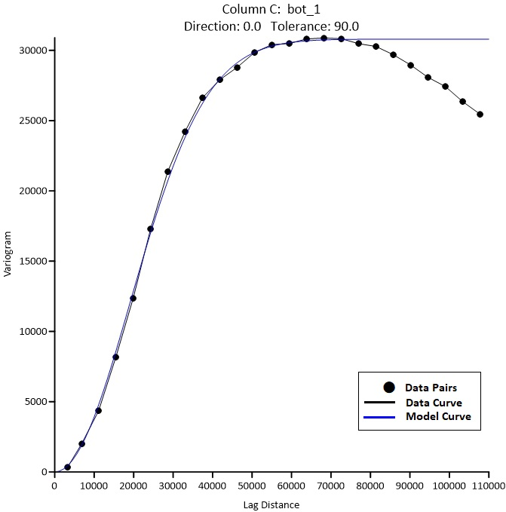
Figure 1 An example figure

Tables
Tables should be included in an editable format and not as images. Number tables consecutively in accordance with their appearance in the text and place any table notes below the table body. Be sparing in the use of tables and ensure that the data presented in them do not duplicate results described elsewhere in the article. Please avoid using vertical rules (Table 1).
Table 1 Title of table 1
Object | ID | Description
A | 1 | A1*
B | 2 | A2
C | 3 | A3
D | 4 | A4
*Table notes

Equations
$f\left(x\right)=a_{0}+\sum_{n=1}^{∞}{\left(a_{n}\cos{\frac{nπx}{L}}+b_{n}\sin{\frac{nπx}{L}}\right)}$ (5)
Please prove a detailed explanation of the equation components.

Acknowledgments
Acknowledgment of funding, support, or assistance in preparing the paper can be included, if applicable.

References
These should be to accessible sources. Please ensure that all work cited in the text is included in the reference list, and that the dates and authors given in the text match those in the reference list. References must always be given in sufficient detail for the reader to locate the work cited (see below for formats). Please make sure to cite all references in the paper.
Reference Citations
References should be cited in the text using author name/s and year of publication in parentheses using APA 7th edition style as follows; one author: (Miller, 1991), two authors (Miller & Smith, 1994), three authors or more (Miller et al., 1995).
Reference List
The references should be arranged according to the alphabetical order by the lead author’s last name. Please make sure to include all authors of references.
Examples of Reference List
Aaron, M. (1999). The future of genomics. In: H. Williams (Ed.), Proceedings of the genomic researchers, Boston.
Brown, B. & Aaron, M. (2001). The politics of nature. In: J. Smith (ed.), The rise of modern genomics, 3rd edn. Wiley, New York, p 234–295.
Glenn, E. P., Brown, J. J., Blumwald, E. (1999). Salt Tolerance and Crop Potential of Halophytes. Critical Reviews in Plant Sciences, 18(2), 227–255. https://doi.org/10.1080/07352689991309207
Chung, S. T. & Morris, R. L. (1978). Isolation and characterization of plasmid deoxyribonucleic acid from Streptomyces fradiae. In Abstracts of the 3rd international symposium on the genetics of industrial microorganisms, University of Wisconsin, Madison, 4–9 June 1978.
Doe, J. (1999). Title of subordinate document. In The dictionary of substances and their effects. Royal Society of Chemistry. Available via DIALOG. http://www.rsc.org/dose/title of subordinate document. Accessed 15 Jan 1999.
Doe, J. (1999). Trivial HTTP, RFC2169. ftp://ftp.isi.edu/in-notes/rfc2169.txt. Accessed 12 Nov 1999.
Healthwise Knowledgebase (1998). US Pharmacopeia, Rockville. http://www.healthwise.org. Accessed 21 Sept 1998.
ISSN International Centre (2006). The ISSN register. http://www.issn.org. Accessed 20 Feb 2007.
Major, M., et al. (2007). Recent developments. In: W. Jones (Ed.), Surgery today. Springer, Dordrecht (in press).
Smith, J. & Brown, B. (Eds.) (2001). The demise of modern genomics. Blackwell, London.
Trent, J. W. (1975). Experimental acute renal failure. Dissertation, University of California.

