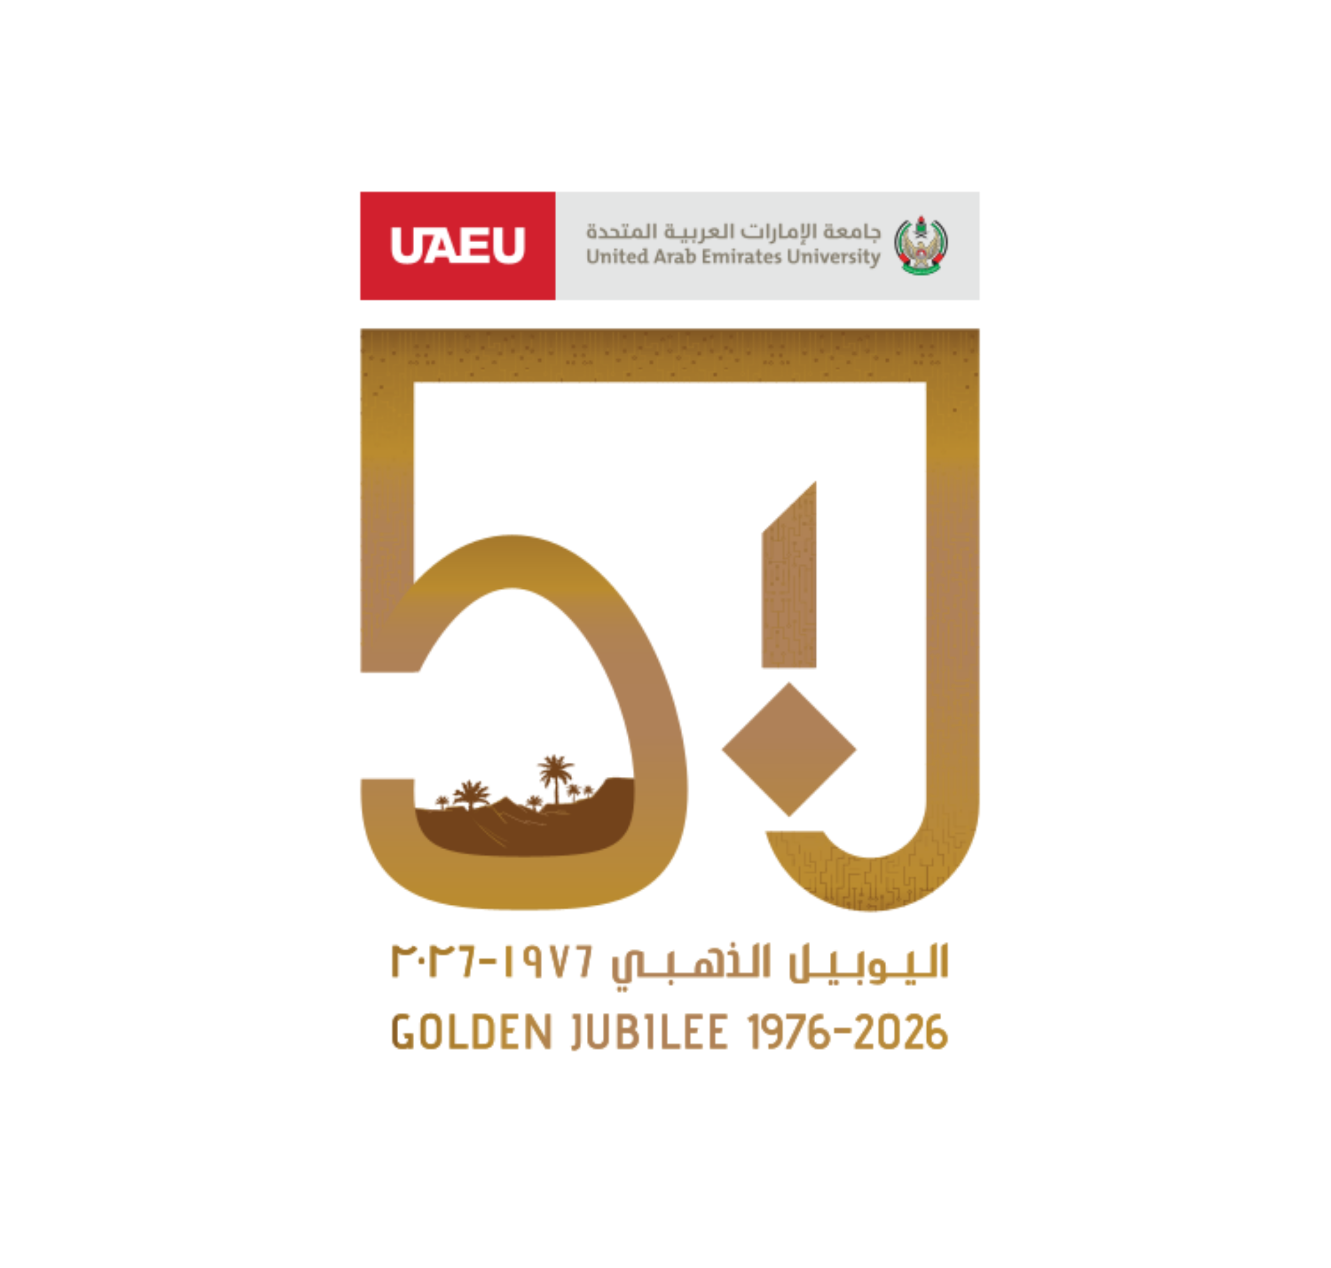

DESERT BY DESIGN
UAEU Desert Architecture & Urbanism Competition | Al Ain Edition 2026
Future Heritage: Designing the Next Layer of Al Ain's Identity
REGISTRATION FORM

Important registration note
Please complete this form in English, sign the declaration, attach eligibility proof where required, and submit it through the official competition channel. Registration is free. The organizer will issue a participant code after the registration is accepted. This form is for administration and eligibility verification only and must not be included in the anonymous final design submission boards.

A. ORGANIZER USE ONLY
Registration / Participant Code | To be assigned by organizer | Date Received
Registration Status | [ ] Received [ ] Accepted [ ] Pending [ ] Not eligible | Reviewed By
Administrative Notes |  | Communication Sent | [ ] Yes [ ] No
Registration Type and Lead Applicant
Fields marked with * are required. The lead applicant receives official updates, participant code, and upload instructions.
B. REGISTRATION TYPE
[ ] Individual applicant | [ ] Team registration | [ ] Student category - Undergraduate
[ ] Student category - Postgraduate | [ ] Professional / emerging professional category | [ ] Mixed/interdisciplinary team - category to be confirmed by organizer

C. LEAD APPLICANT / TEAM COORDINATOR DETAILS
Full Name * |  | Preferred Name
Email Address * |  | Mobile Number *
Nationality |  | Emirate / City
Institution / Company * |  | Department / Discipline
Current Status * | [ ] UG student [ ] PG student [ ] Graduate [ ] Professional | ID Number
Qualification / Graduation Year |  | Proof Attached | [ ] Enrollment [ ] Graduation [ ] Professional
Portfolio / LinkedIn URL | Optional | Postal Address | Optional

Eligibility and Discipline
Each applicant/team member must satisfy the competition eligibility rules and provide proof if requested.
D. ACADEMIC / PROFESSIONAL ELIGIBILITY CONFIRMATION
[ ] I am currently enrolled in a UAE-based university or higher education institution. | [ ] I am a graduate of a UAE-based university or higher education institution.
[ ] I am registering as a professional or emerging professional in a related design field. | [ ] I understand that proof of enrollment, graduation, or professional status may be requested.
[ ] I understand that the organizer may reject incomplete or non-eligible registrations. | [ ] I confirm that all contact details provided are accurate.

E. RELATED FIELD / DISCIPLINE
[ ] Architecture | [ ] Architectural engineering | [ ] Urban design / planning | [ ] Landscape architecture
[ ] Interior design | [ ] Engineering | [ ] Sustainability / environmental design | [ ] Allied field - specify: ______________________________

Eligibility note
The competition welcomes students, postgraduate students, professionals, and emerging professionals from architecture, architectural engineering, urban design, planning, landscape architecture, interior design, engineering, sustainability, and allied fields. All participants must meet the UAE-based higher education eligibility requirement as stated in the competition brief.

Team Members
List all participants. Add extra rows/pages only if needed and permitted by the organizer.
F. TEAM COMPOSITION
No. | Full name | Role | Category | Institution / Company | Email | Mobile | Proof attached
1 |  |  | Student UG / PG / Professional |  |  |  | [ ] Yes [ ] No
2 |  |  | Student UG / PG / Professional |  |  |  | [ ] Yes [ ] No
3 |  |  | Student UG / PG / Professional |  |  |  | [ ] Yes [ ] No
4 |  |  | Student UG / PG / Professional |  |  |  | [ ] Yes [ ] No
5 |  |  | Student UG / PG / Professional |  |  |  | [ ] Yes [ ] No
6 |  |  | Student UG / PG / Professional |  |  |  | [ ] Yes [ ] No

Team category note
If a team includes participants from different categories, the final prize/category classification will be confirmed by the organizer. The lead applicant is responsible for ensuring that all team members receive official updates and comply with the rules.

Preliminary Project Profile
This information supports registration administration. Final design details may evolve before submission.
G. OFFICIAL SITE SELECTION
Selected / intended site * | Site description
[ ] Site 1 | Al Ain Oasis Edge Redevelopment Area - heritage marketplace / souq-related redevelopment opportunity
[ ] Site 2 | Al Rubainah Cultural Destination Site - cultural destination, landmark, or visitor hub opportunity
[ ] To be confirmed | Final submission must be located within one of the two official sites. Alternative self-selected sites are not permitted.

H. ELIGIBLE PROJECT TYPE / SCOPE
[ ] Heritage-linked visitor, research, or community infrastructure | [ ] Climate-responsive pavilion, interpretive centre, or learning space
[ ] Adaptive reuse or contemporary addition to existing built elements | [ ] Public-realm and landscape intervention improving shade, movement, comfort, and interpretation
[ ] Archaeological interpretation route, viewing structure, threshold, gathering space, or site narrative system | [ ] Small urban / landscape connector improving arrival, orientation, and visitor experience

I. PRELIMINARY PROJECT INFORMATION
Working Project Title |  | Primary Site | Site 1 / Site 2
Main Design Focus | Heritage / climate / public realm / tourism / other | Approximate Scale | Pavilion / landscape / public realm / mixed
Preliminary concept statement (optional at registration; max. 150 words):

Submission Awareness and Compliance
The final design package will be submitted later according to official website instructions.
J. FINAL SUBMISSION REQUIREMENTS ACKNOWLEDGMENT
[ ] Four A2 landscape-oriented presentation boards with drawings, diagrams, visualizations, and explanatory text.
[ ] One project preview image suitable for website/publicity use.
[ ] Project statement of up to 400 words explaining the concept, official site response, and design approach.
[ ] All written content should be in English unless updated official instructions state otherwise.
[ ] Presentation boards must be anonymous and must not include participant names, emails, logos, university marks, or other identifying information.
[ ] No video files are required unless announced separately by the organizer.
[ ] Final file format, file-size limit, naming convention, and upload link will be confirmed on the official website.
[ ] This registration form must not be uploaded as part of the anonymous final boards.

K. RECOMMENDED SUBMISSION CONTENT
[ ] Design innovation and contextual heritage | [ ] Economic impact and civic engagement
[ ] Environmental responsiveness and sustainability | [ ] Presentation and communication

Schedule and Key Rules
The exact submission deadline and time zone must be checked on the official competition website.
L. COMPETITION SCHEDULE
Milestone | Date / Period
Launch | July 2026
Free registration period | July to August 2026
Submission deadline | Early October 2026 - exact date/time to be announced
Jury evaluation | October 2026 - exact date/time to be announced
Awards exhibition ceremony | November 2026 - exact date/time to be announced

Free registration
There are no registration fees. Participants must still complete registration to receive official updates, participant code, and submission/upload instructions. Public updates on the official competition page supersede earlier draft dates.

M. JURY, PUBLICITY, AND CONDUCT AWARENESS
[ ] Participants must not contact jury members directly.
[ ] Winning and selected projects may be presented through UAEU channels, media, exhibitions, websites, social media, and academic events.
[ ] Participants retain authorship while granting permission for competition, exhibition, educational, and promotional publication.
[ ] The organizer may request editable files, high-resolution images, or author details from shortlisted and winning participants after judging.

Declarations and Attachments
The lead applicant must sign this declaration. For team submissions, all members should sign where possible.
N. PARTICIPANT DECLARATIONS
[ ] I/we confirm that the information provided in this registration form is true and complete.
[ ] I/we confirm that the proposed work will be original and will not infringe third-party rights.
[ ] I/we understand that all final submission boards must remain anonymous and free from identifying information.
[ ] I/we understand that participants must not contact jury members directly, as this may compromise fairness and may lead to disqualification.
[ ] I/we understand that the organizer may reject incomplete, late, non-anonymous, non-compliant, or inappropriate submissions.
[ ] I/we grant the organizer permission to publish submitted material for competition, exhibition, educational, and promotional purposes, while retaining authorship of the work.
[ ] I/we confirm that images, maps, diagrams, AI-generated elements, models, and third-party materials used in the submission will be legally usable for publication.
[ ] I/we understand that any future implementation, research development, exhibition, or construction opportunity will be subject to separate agreements, approvals, and permissions.
[ ] I/we consent to the use of the personal information in this form for registration, eligibility verification, communication, competition administration, and prize processing if applicable.

O. REQUIRED ATTACHMENTS CHECKLIST
[ ] Completed and signed registration form | [ ] Proof of enrollment or graduation from a UAE-based higher education institution, if applicable/requested
[ ] Proof of professional affiliation or graduate status, if applicable/requested | [ ] Team authorization/consent if the lead applicant submits on behalf of a team
[ ] Any additional documents requested by the official platform or organizer | [ ] No registration fee payment is required

Signatures and Submission
Signatures may be completed electronically or by hand after printing.
P. SIGNATURES
Participant | Full Name | Signature | Date
Lead Applicant
Member 2
Member 3
Member 4
Member 5
Member 6

Contact and submission channel
Submit this completed form and attachments through the official competition channel. Email: desertbydesign@uaeu.ac.ae. All Q&A should be submitted through the official contact channel; public clarifications will be shared with all participants to ensure equal access to information.

