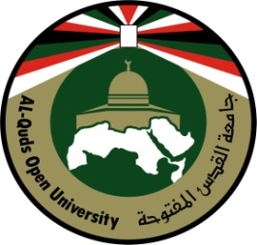
Al-Quds Open University

The reality of the gifted students’ programs in Palestine: Jerusalem “Model”
Prepared by:
Manal Al-Qaissi
A faculty member / Al-Quds Open University
Abstract
This study aims to identify the reality of the Palestinian experience regarding their care of the gifted and outstanding students in East Jerusalem’s schools, more specifically: what are the programs and the activities that are offered to these students in Jerusalem? The study also seeks to find ways to enhance and develop these programs from the perspective of those in charge of these schools (principals, teachers and mentors etc...).
This study took place at talented and outstanding students’ schools in East Jerusalem, both that belong to the Israeli and the Palestinian Ministry of Education. The most prominent result pointed to the limited number of these schools and its’ various potentials, actually these schools are limited to two schools that belong to the Israeli Ministry of Knowledge and they are from the fourth grade until matriculation “Bagrut”(which is equivalent to a high school diploma). These schools focus its’ effectiveness on preparing the valedictorian students in the subjects of engineering, technology and high-tech, it also allows these students to choose the most preferable scientific subject to them: chemistry, biology or physics. In addition to compulsory subjects: Arabic, Hebrew, English and religion.
As for the schools belonging to the Palestinian Ministry of Education, they are almost
non-existent limited to a few participations of the gifted and outstanding students in scientific and sports activities or poetry and arts programs etc... Of course, these are supervised by the Palestinian Ministry of Education throughout the country.
Furthermore, there is cooperation with private organizations specialized in providing care for gifted and valedictorian students, such as; Al-Nayzak organization for scientific innovation (it is an organization for gifted students launched in Jerusalem and spread throughout the world, offers its services free of charge for these students until they start in the labor market).
This study pointed to a number of recommendations, the most noticeable ones were: to provide more financial and moral support by relevant ministries which take care of outstanding and talented students, to raise the parents’ -of these students- awareness so they could be able to discover and nurture their children’s talent early, to gain experiences and learn skills through going throughout the world and then apply them locally after making sure that they are suitable for the Palestinian reality, to launch educational media specialized in the issues of the gifted and the valedictorian students and to increase the community’s awareness regarding noticing these students’ cases and taking care of them early.

